# Canadian CubeSat Project 2:

## What is the Canadian CubeSat Project?

<https://www.asc-csa.gc.ca/eng/satellites/cubesat/what-is-the-canadian-cubesat-project.asp>

The Canadian CubeSat Project (CCP) was announced in April 2017. The CCP is providing professors in post-secondary institutions with an opportunity to engage their students in a real space mission. Through this national initiative, winning teams of professors and students are offered the unique opportunity to design and build their own miniature satellite called a CubeSat.

A total of 15 grants ranging from $200,000 to $250,000 was awarded following an Announcement of Opportunity (AO).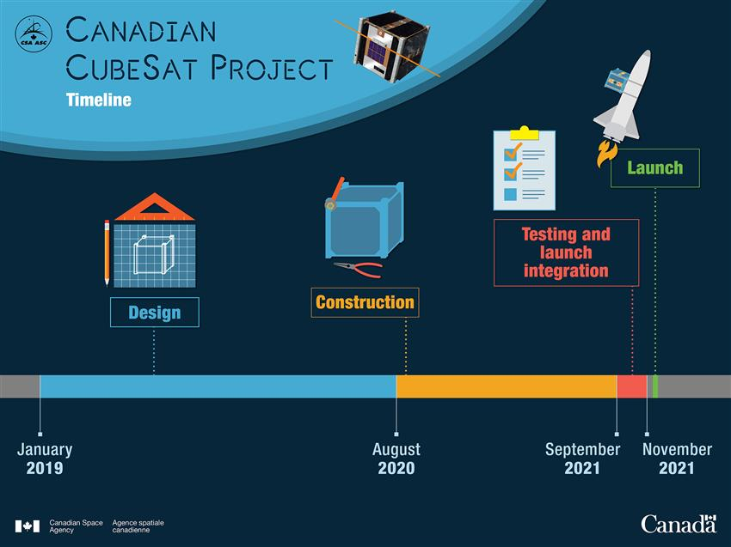

Student teams across Canada are now hard at work to first design and then build their CubeSats. Once tested and ready for space, the CubeSats will be launched to and deployed from the International Space Station (ISS) in 2020–2021. The student teams will then operate their satellites and conduct science according to the objectives of their missions, which could last up to 12 months.

Throughout the project, CSA experts, as well as representatives from the Canadian space industry, will guide professors and students to optimize the success of each mission. This unique hands-on experience will provide students with the opportunity to acquire expertise in a wide variety of areas – ranging from science and technology to communicating their work to the public – and develop invaluable skills that will prepare them to become Canada's next generation of space innovators.

## Objectives:

* Increase students' interest in STEM, particularly in space domains;
* Develop students' expertise in space domains;
* Give students hands-on experience and prepare them to enter the job market; and
* Advance space science and/or technology.

Must be Canadian post-secondary institutions (colleges and universities).

## Link To selected teams:

<https://www.asc-csa.gc.ca/eng/satellites/cubesat/selected-teams-map.asp>

## What is Cubesat:

<https://www.asc-csa.gc.ca/eng/satellites/cubesat/what-is-a-cubesat.asp>

## CCP2:

The Canadian Space Agency seems very keen on having a second round of CCP action! This is mostly word of mouth right now, and funding would only be given after proposals are looked over and such (~6 months ish after proposals given)